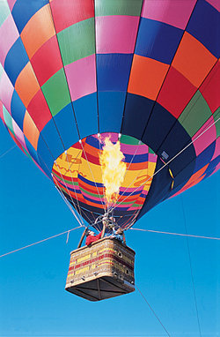[**VISUAL PHYSICS ONLINE**](http://www.physics.usyd.edu.au/teach_res/hsp/sp/spHome.htm)

**THERMODYNAMICS**

**METHODS OF HEAT**

**TRANSFER**

**CONVECTION**

Liquids and gases are **fluids**. The particles in fluids can move from place to place. **Convection** occurs in fluids when the particles with higher kinetic energy move and take the place of particles with less kinetic energy. Thus, energy can be transferred from hotter regions to cooler regions by the movements of molecules over large distances in the fluid.

**Convection is the transfer of energy from a region of higher temperature to a region of lower temperature due to the motion of the particles of the fluid**.

**Convection** above a hot surface occurs because hot air expands, becomes less dense and rises. This known as **natural** or **free convection**.

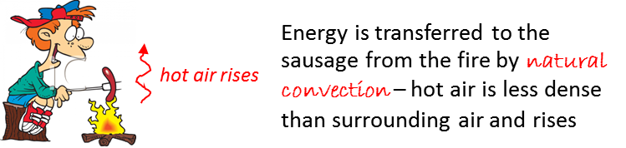

Energy is transferred by convection when there is a difference in temperature between two parts of a fluid. When this temperature difference exists, hot fluids rise and cold fluids sink setting up **convection currents** in the fluid.

When part of a fluid is warmed, it expands and becomes less dense than its surroundings. The fluid rises until its density reaches that of the surroundings, and as it cools further it becomes more dense and sinks and convection currents are created. An expanding fluid cools because the molecules have more collisions with receding ones than with approaching ones, reducing their average translational kinetic energy during the collisions and hence the temperature decreases.

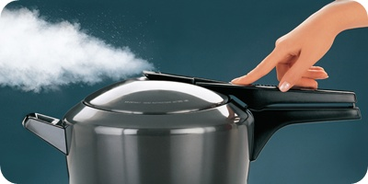An example of the cooling by expansion occurs when steam (gas) escapes through the nozzle of a pressure cooker and condenses as it cools. The gaseous steam (water vapour) is invisible, the cloud you see is the condensed water vapour (liquid).

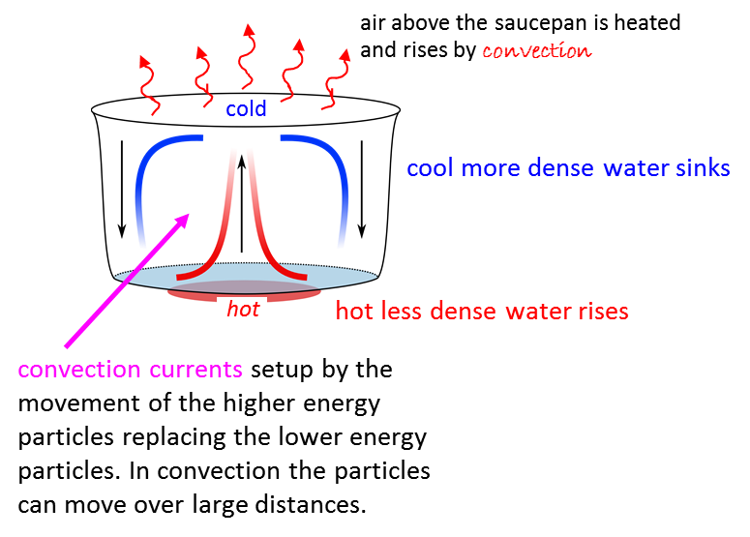

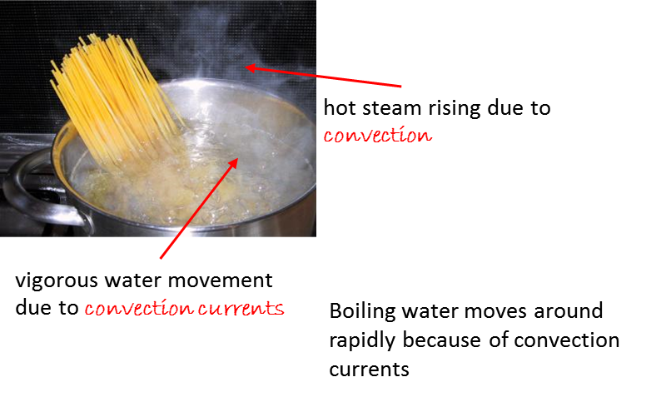

**Convection is a beautiful thing:**

**chunks of fluid carry energy**

**from one part to another**

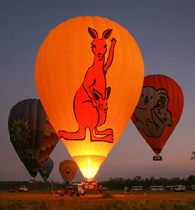People make use of convection when they go hot air ballooning. Hot air rises because it expands when heated and therefore becomes less dense. The hot air is then captured by the balloon. The volume of the balloon is chosen so that the buoyancy force on it is larger than the weight of the balloon and the weights attached to it (that includes people), so the balloon rises. The rising hot air eventually cools, which means now it is more dense and can start falling again. But it can't go straight down since there is rising hot air below it. Therefore, it shifts sideways then starts to fall. Air circulating in this way is called a **convection current**.

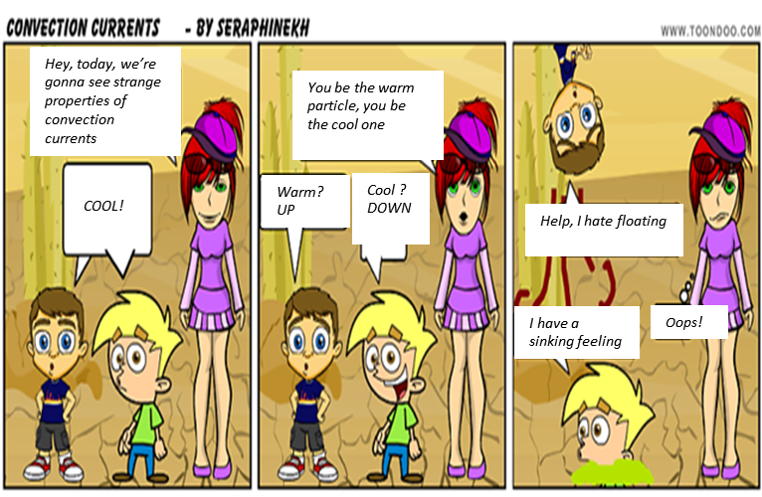

**Convection currents on a global scale**

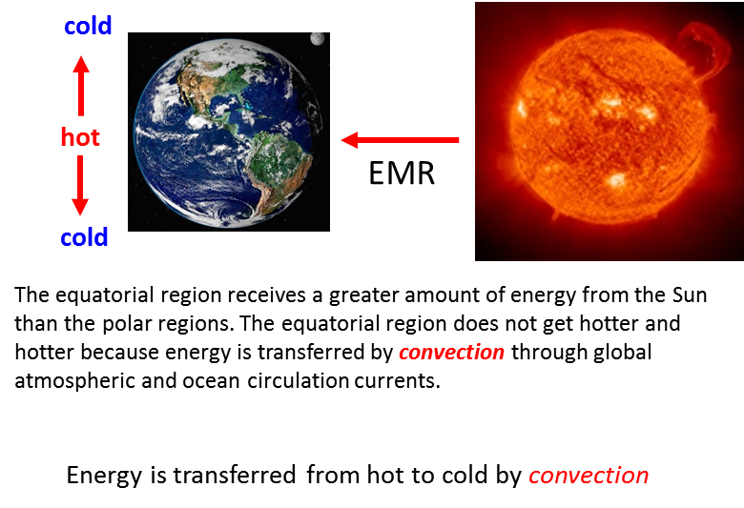

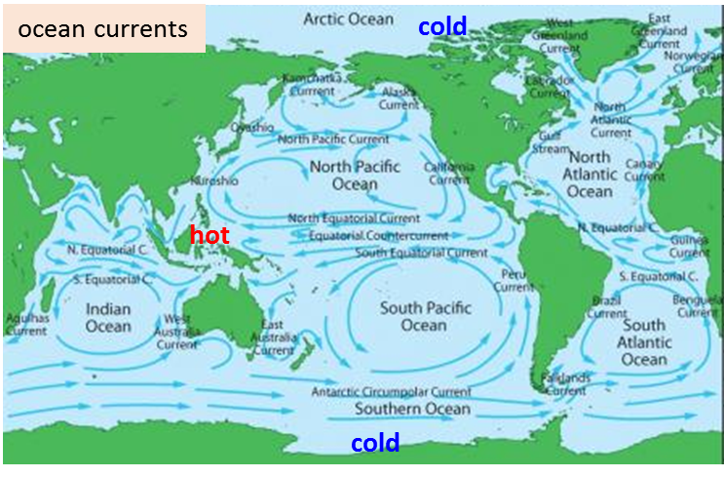

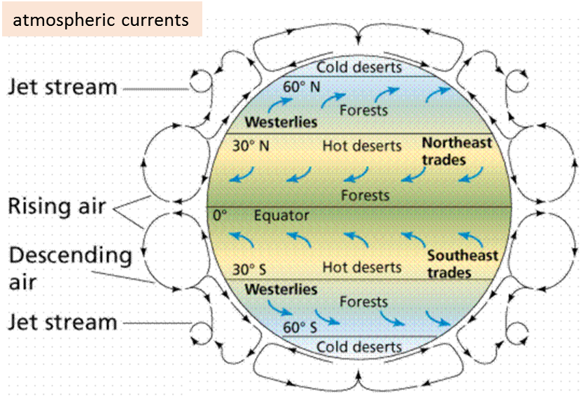

**Forced convection** is when the movement of the fluid is boosted by an external source such as a fan or pump.

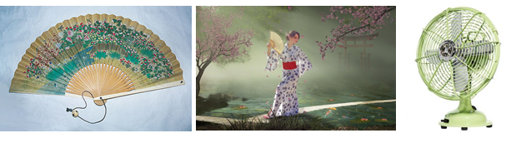

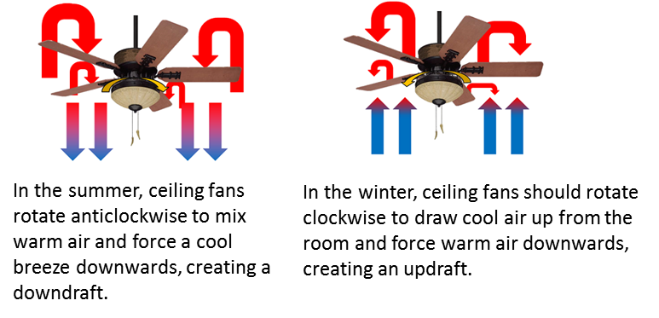

**Convection ovens** have a fan inside which speeds up the cooking by increasing the circulation of the hot air and producing a more uniform temperature distribution within the oven.

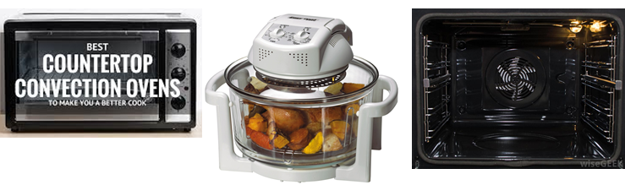

In an advertisement for convection ovens it was written “*The fan produces an even distribution of heat within the oven* … “.

What is wrong with this statement?

***Thinking questions on CONVECTION***

How does **convection** relate to each one of the images?

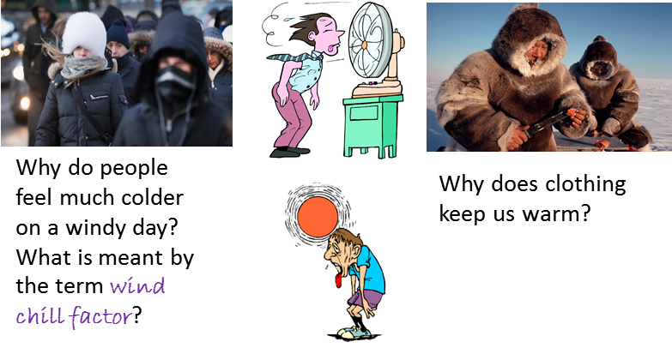

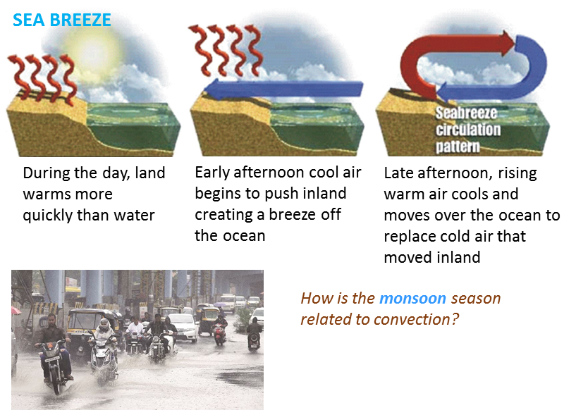

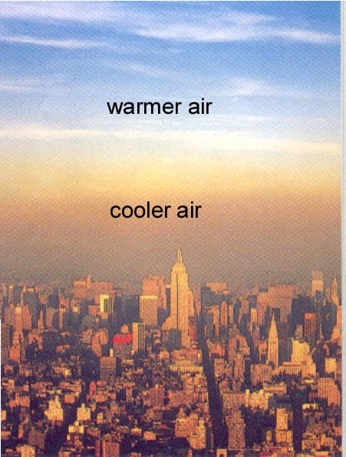

Explain how convection is related to air pollution problems.

Temperature inversion prevents air rising and the dispersing the pollution

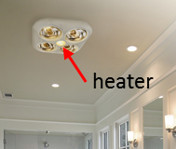

Why is it not a good idea in a bathroom to have a heater near the ceiling?

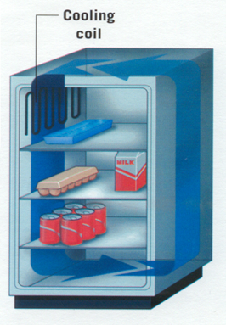

What is the coldest part of a refrigerator? Why are the coiling coils near the top?

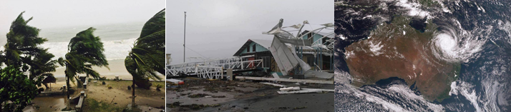What causes a **wind** and where does the **energy** associated with a **cyclone** come from?

What is a **cloud**?

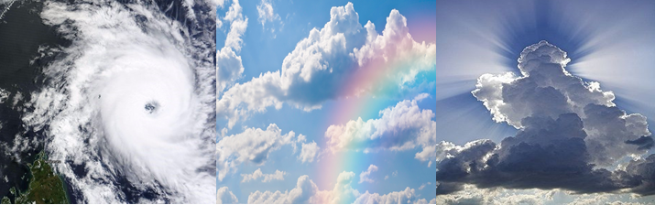

[VISUAL PHYSICS ONLINE](http://www.physics.usyd.edu.au/teach_res/hsp/sp/spHome.htm)

If you have any feedback, comments, suggestions or corrections please email:

Ian Cooper School of Physics University of Sydney

ian.cooper@sydney.edu.au